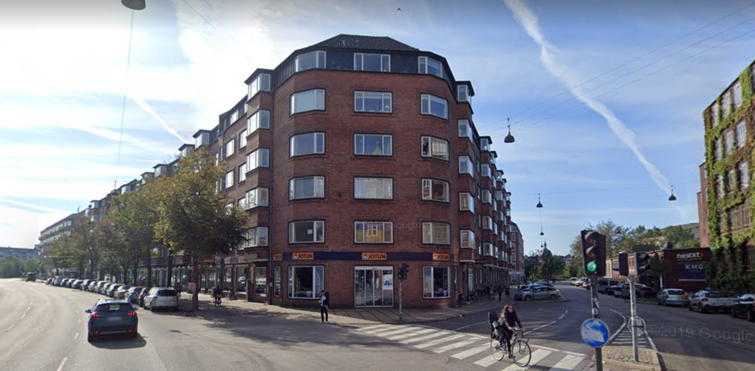

Dear tenant of commercial property in Gammel Ladegaard

Gammel Ladegaard is a charming building with a long and exciting history. On our web page (www.gammel.ladegaard.dk) you can read about our building, see news, and get contact information – among other things.

Our building houses different types of commercial activities as well as residences for owners and tenants, and all parties want a well functioning neighburhood.
For any conduct in our building, we have a house order which is approved at our general assembly, and which can be found on our homepage under the section “Download” (http://gammel-ladegaard.dk/download/).

On the next page, you will find a summary of the relevant matters for you as a tenant of commercial property in Gammel Ladegaard. The summary represents the most important matters from the house order of Gammal Ladegaards owners association as well as applicable legislation and official guidelines from the authorities.

You are always welcome to reach out to us if you have any questions, or matters you would like to discuss
Best regards
Board of owners association, Gammel Ladegaard

For tenants of commercial property in Gammel Ladegaard
NOISE:
- Cf. to our house order, any type of unnecessary noise must be avoided. Especially between 22 and 07, calm and order must be upheld.

WINDOWS AND DOORS:
- All windows and doors must be closed, ref to the Municipality of Copenhagen § 8 in Regulations regarding environmental requirements related to decoration and management og restaurants in the Municipality of Copenhagen

HANDLING OF WASTE:
- Rules relating to commercial waste are found in the waste order as well as in the regulation for commercial waste – ref to Waste order and Regulations for commercial waste.
- The Municipality of Copenhagen has summed up the guidelines for disposal of waste for companies here: https://www.kk.dk/artikel/bortskaffelse-af-affald-fra-virksomheder.
- From the guidelines it is clear that you and your company are obligated to handle your waste correctly, both for residual waste, and for recyclable waste.
- For residual waste, your company can use the our waste facilities as needed. Residual waste is generally speaking the waste that that can be found in the waste bin in the break room.
- For recyclable waste, your company are free to use our waste facilities, under the premise that each of the recyclable fractions do not exceed what is used by an average household.
- It is considered more than an average household if your company has:
    - More than 10 meduim sized cardboard boxes a week, og more than 5 very big boxes a week
    - More than 6 bags of food waste a week

- If your company has more waste than an average household, you can make an appointment for trash with the Municipality of Copenhagen. We have established a separate waste facility just across the gate, for extra containers for tenants of commercial property. Any use of these facilities must be arranged with the janitor.
As a commercial tenant, You are responsible for conducting yourself and your business in accordance with waste management. We encourage you to respect this if you are conducting business that produces more waste than an average household!

DRAINS AND GREASE TRAPS:
- Perform general cleaning of drains and grease traps every 6 months.
- Failure to clean and maintain can result in odor and can attract rats.
CONNECTION OF EXTRACTOR HOOD AND OTHER TECHNICAL INSTALLATIONS:
- Together with your landlord, you are responsible for ensuring that any connection to chimney, vent, as welk as the installation hereof is approved by the Municipality of Copenhagen

BACK YARD:
- The back yard can only be used for short breaks for employees of the tenants. It is prohibited to have guests, customers of the like in the back yard.
- Driving in the back yard is no longer permitted. In case of need to perform bigger scale work, it should happen from the street side of the building. If work needs to happen via the back yard, it requires approval from the Board of owners association. In case a permission is granted, it will include a requirement to place driving plates from the gate to the working site, so as to protect the back yard.

EXTERNAL SIGNS:
- Establishment of signs must happen in accordance with the Commercial Rent Act § 39 and in dialogue with the Board of owners association.

